

**CS 306, Database Systems**

**Project Phase 3**

**Applying Indexing on Tables and Analyzing the Effectiveness**

Can Çiftçioğlu, 26532

**Submission Date:** 24.12.2023

Figure 1 depicts the result of a natural join operation between the "users" and "education" tables without the use of dummy values. This figure illustrates the combined data set where matching rows from both tables are included in the result set.

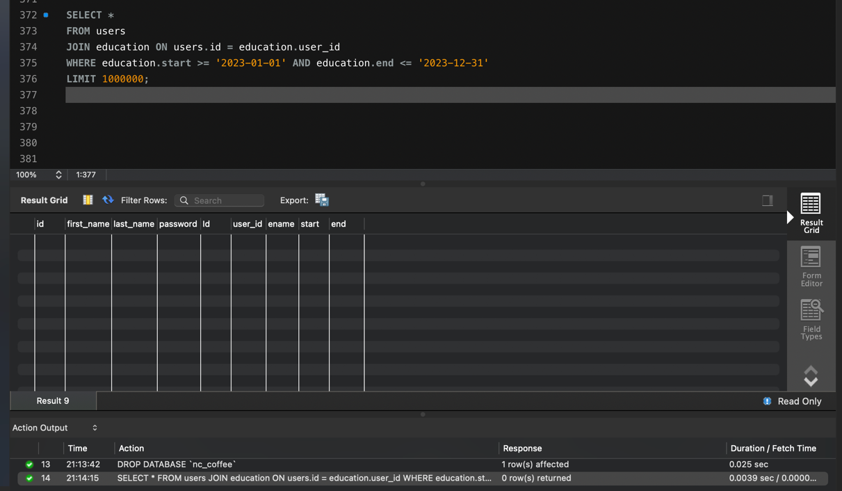

*Figure 1: users and education natural join without dummy values*

Figure 2 represents the outcome of a natural join operation between the "users" and "education" tables, but this time with the inclusion of dummy values. These dummy values are used to populate the tables and ensure that each table contains at least 1 million records.

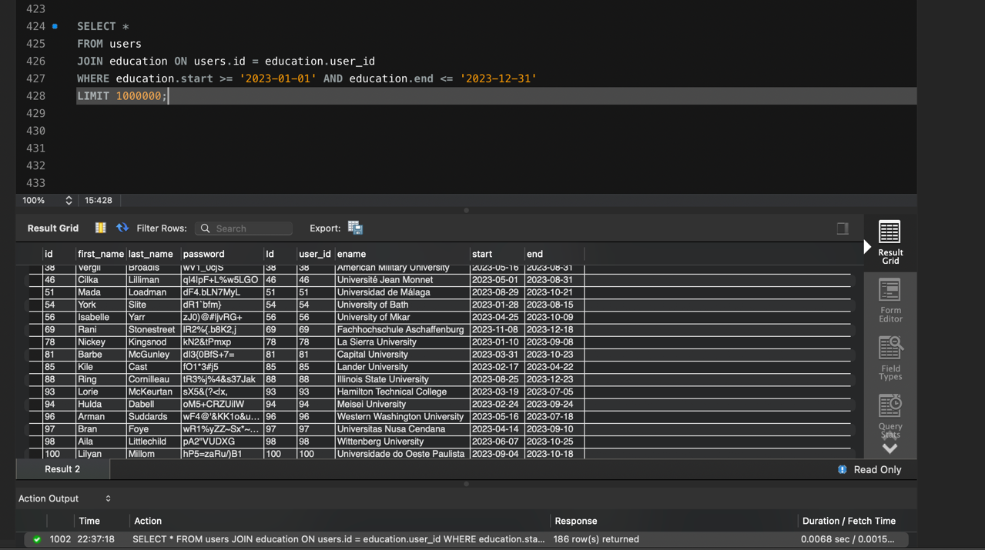

*Figure 2: users and education natural join with dummy values*

Figure 3 shows the process of creating indexes for the "first name" and "last name" columns in one of the tables. Indexing is performed to improve query performance by allowing for faster data retrieval based on these specific columns.

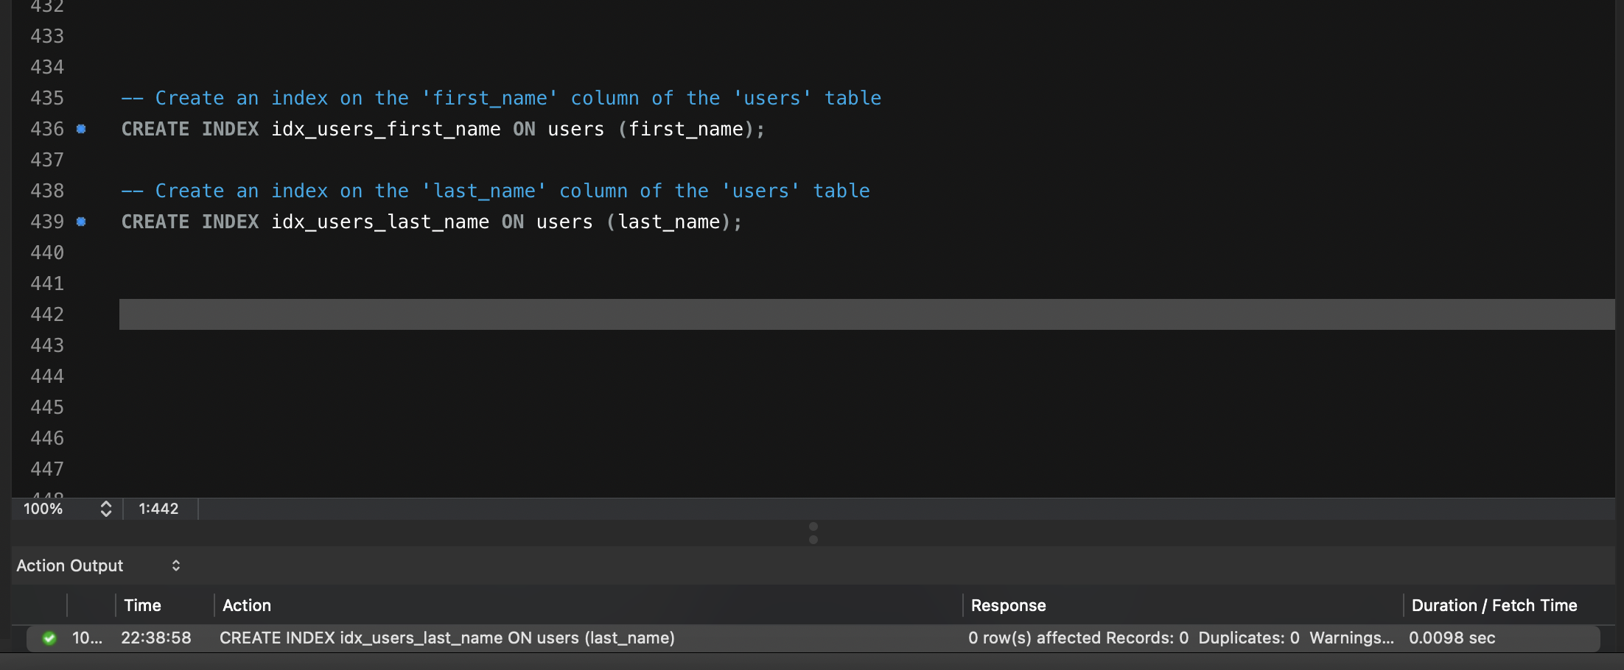

*Figure 3: creating index for first and last name*

Figure 4 illustrates the indexing process specifically applied to the "education" table. Indexes are created to optimize query performance when searching or filtering based on the columns within the "education" table.

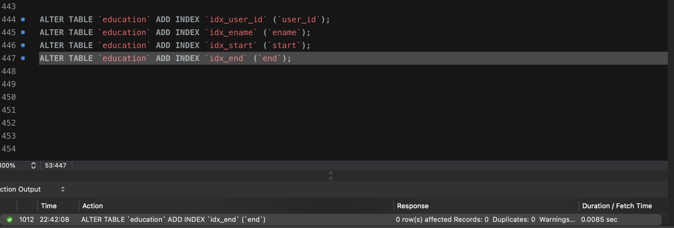

*Figure 4: creating index for education table*

Figure 5 displays the timing results of executing queries that involve joining the "users" and "education" tables. The figure presents a comparison of execution times for queries before and after the application of indexes. This timing data helps evaluate the effectiveness of indexing in improving query performance.

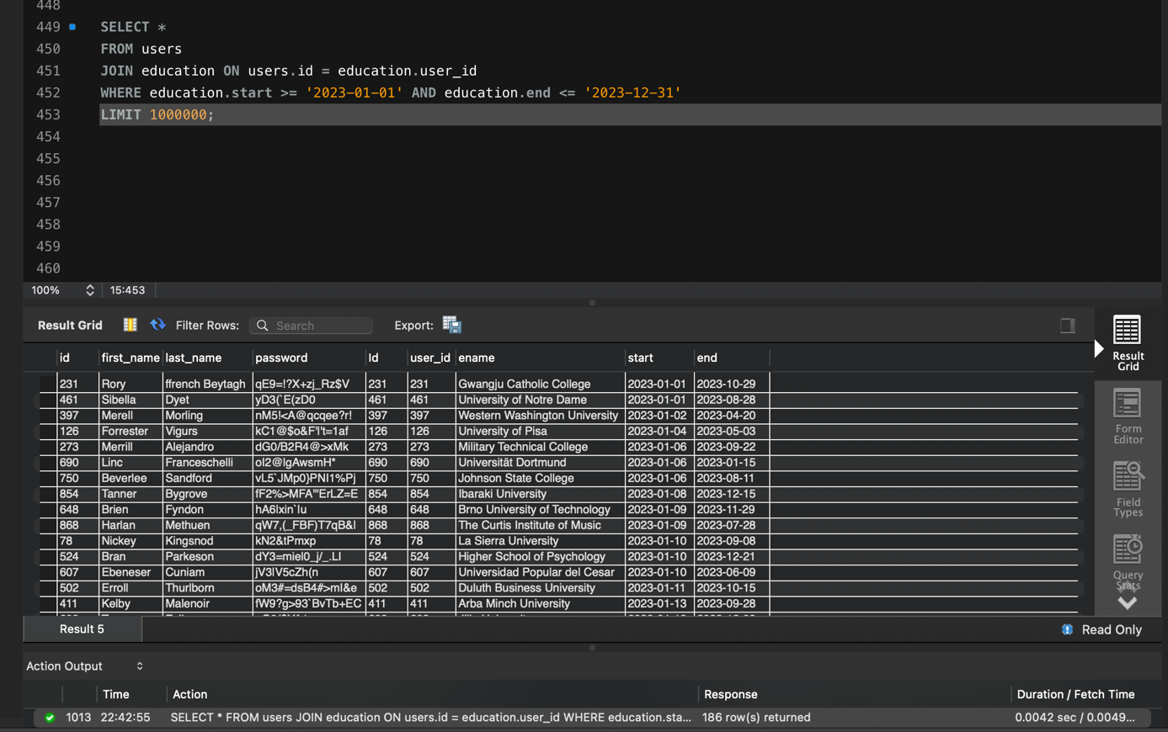

*Figure 5: users and education on timing*